Andrew Dykman – Lab 8 (With Screenshots)– Business Concepts for Application Developers – 8/15/2012

Task 1, 2a.)
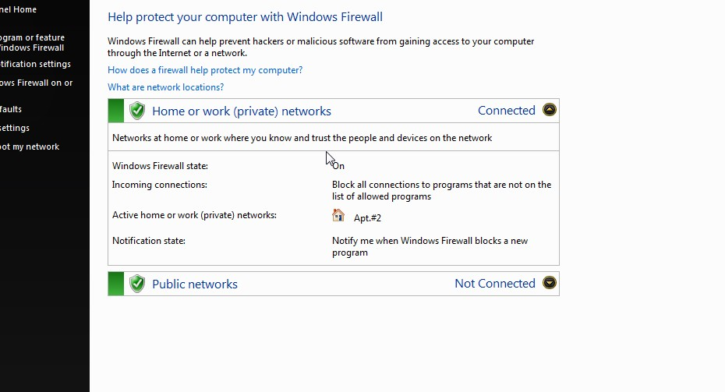
Status: Secured.

Task 2, 1.) Sideshow presentation about Perimeter Firewalls:

Slide 1:
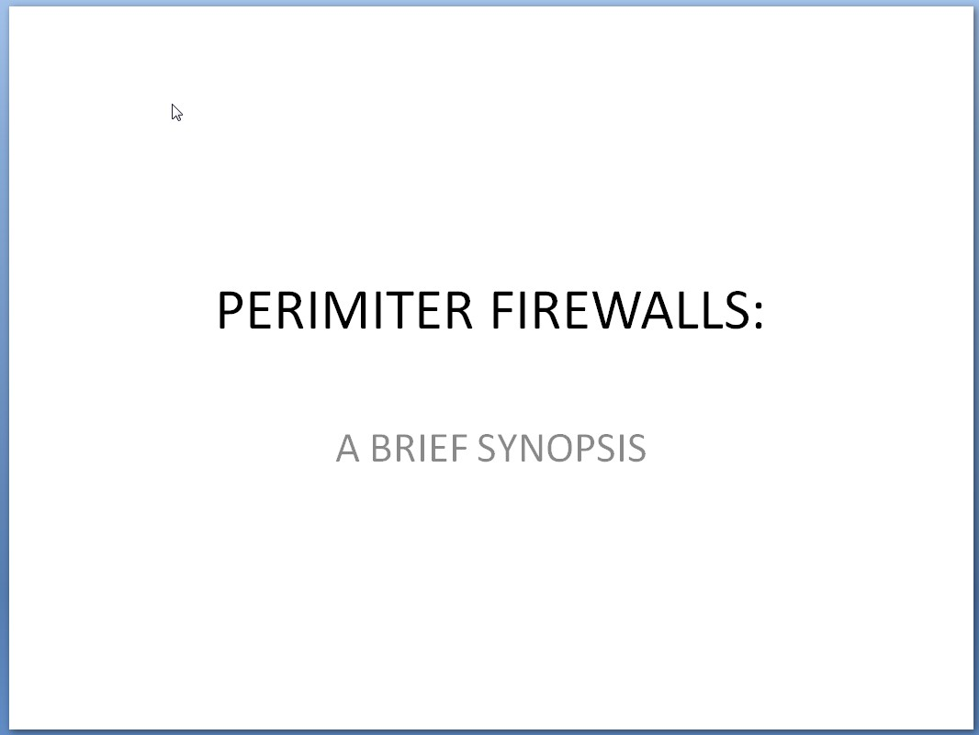
Slide 2:
(next page)

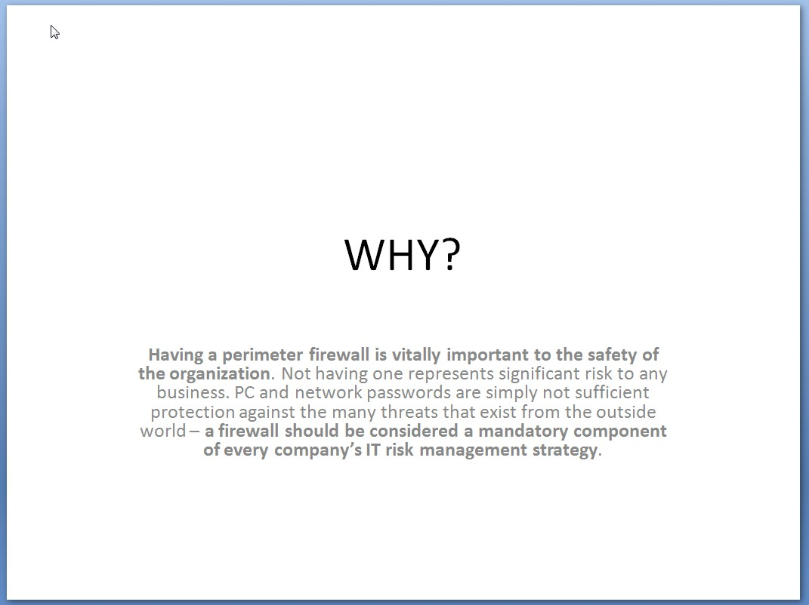

Slide 3:
(next page)

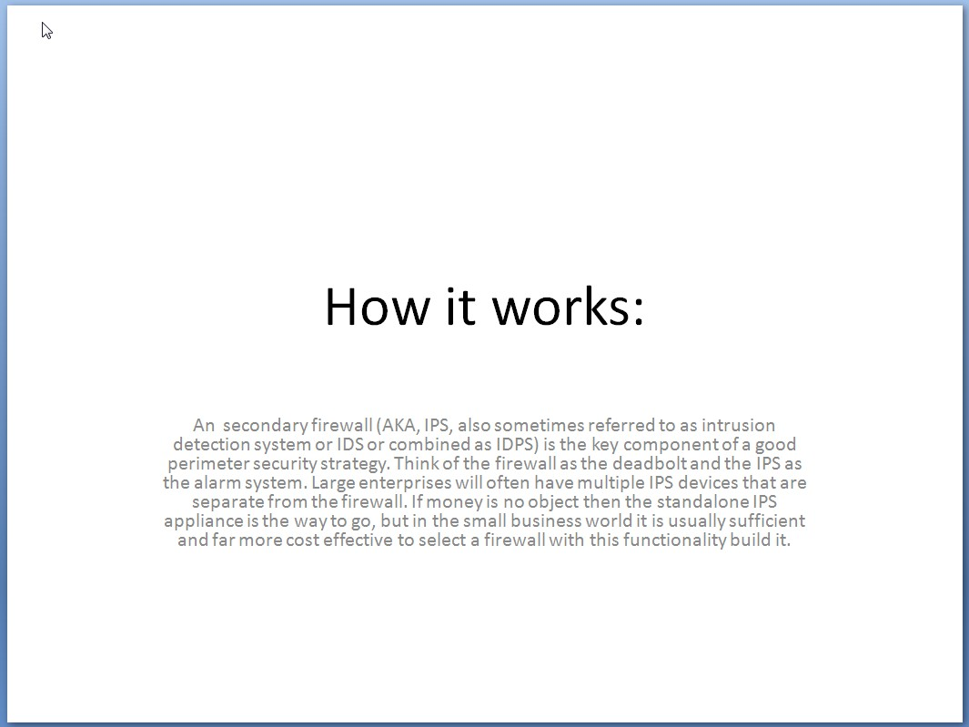

Slide 4:
(next page)

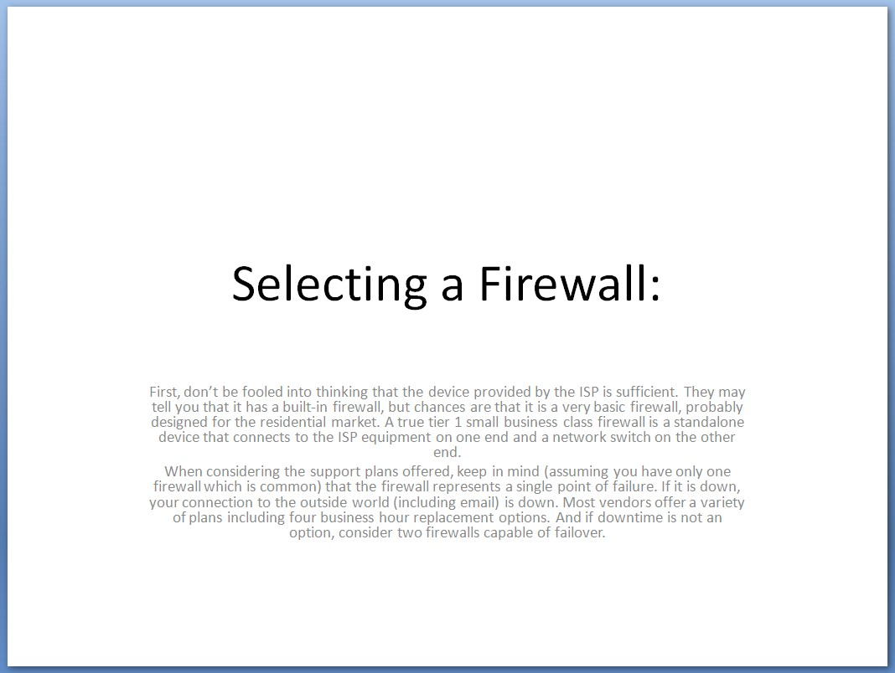
Slide 5:

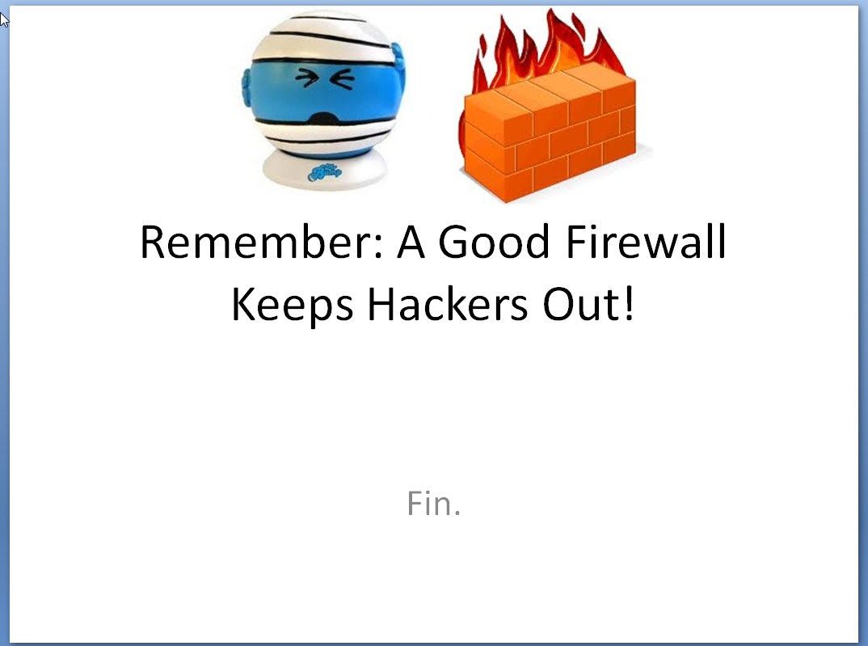

Task 2a.) Yes, one is external and the other is internal. (Such as an external firewall and IDS, or Host-Based Intrusion Prevention System)

Task 3.)

WEP:
- IV is only 24 bits.
- Master keys are used directly.
- No limit on using the same IV value more than once.

WPA:

- IVs protected through the use of the TSC, or TKIP sequence counter.
- Master keys are never directly used.
- Very good key management
- Impressive message integrity checking
- IV length has increased to 48 bits from 24 bits (allows 500 trillion possible key combinations)

